Team name: Name 1, Name 2, Name 3, Name 4
Network Documentation
Hardware 1: Networks

School of ICT
Metropolia University of Applied Sciences
14.1.2024 (v1.0)
Version history

Ver | Description | Date | Author(s)
1.0 | Created structure for the final assignment report. | 14.1.2024 | Saana Vallius
1.1 | Changed the name to Network Documentation Template. Modified the content and instructions to match the new Networks exercises. | 12.1.2025 | Saana Vallius

Contents
1 Introduction 1
2 Setting up the Network 1
2.1 Test Results 2
3 IP Addressing 2
3.1 Test Results 3
4 Setting up DDNS and Port Forwarding 3
4.1 Test Results 3
5 Setting up the Raspberry Pi Pico 3
5.1 Test Results 3
References 4

Introduction
This report template is for network documentation of the Networks part of the Hardware 1 course. The section headings of the document correspond to the weekly assignments on the Networks course. Document your work on the assignments under each section. Remove the instruction texts and replace them with your own content. The goal is to introduce the steps you went through in setting up the network. You may add your own subsections if needed. You should include figures, screenshots, tables, lists or other visual objects into your text to explain your work in a clear and interesting way. When searching for information for the weekly exercises, remember to include any used sources in the reference list of this document and mark the references in the text.

The document begins with this Introduction section. In the Introduction you must briefly introduce the network and the meaning of this document. Please include the following:

- The goals for the network documentation.
- The motivation for completing the final assignment: Why is it done?
- The contents of this document.

A suitable length for the Introduction in this report is 0.5-1 pages.

Setting up the Network
Explain the steps you took when working on the Week 1: Setting up the Network exercises. Remember to include screenshots and other illustrations. Remember to list any used references in the reference list.

We took the router out of the box and powered it on. We also slapped the ‘group 4’ sticker on it to mark our territory. We had some trouble setting the router up, so we wrangled with it for a bit. We then followed the instructions on the manual that came in the box, but it still did not work. Then after some further finagling we found it in the list of networks ‘asus_00’
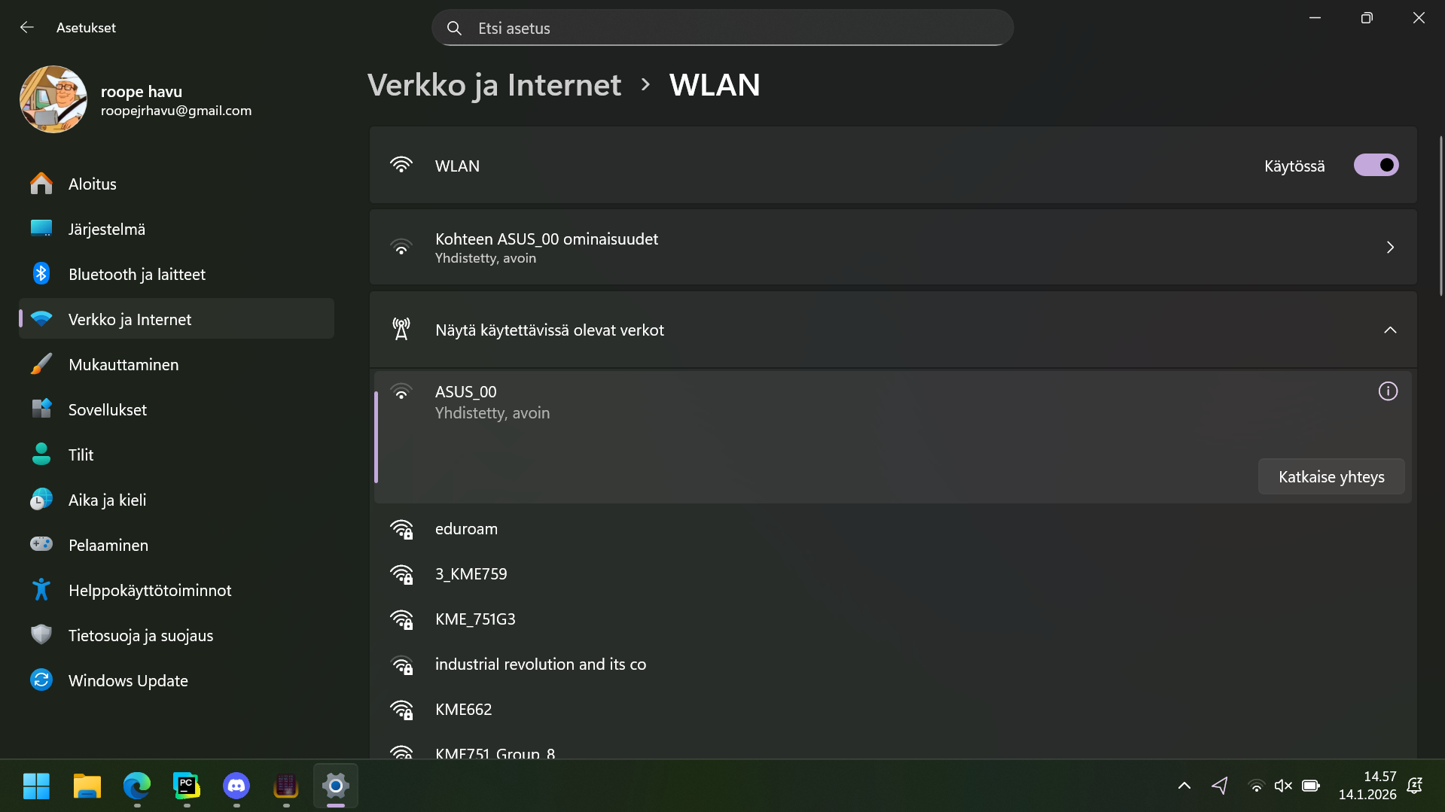
We set up the router with the name ‘KME761_Ryhmä4’ and set up an admin for the network.
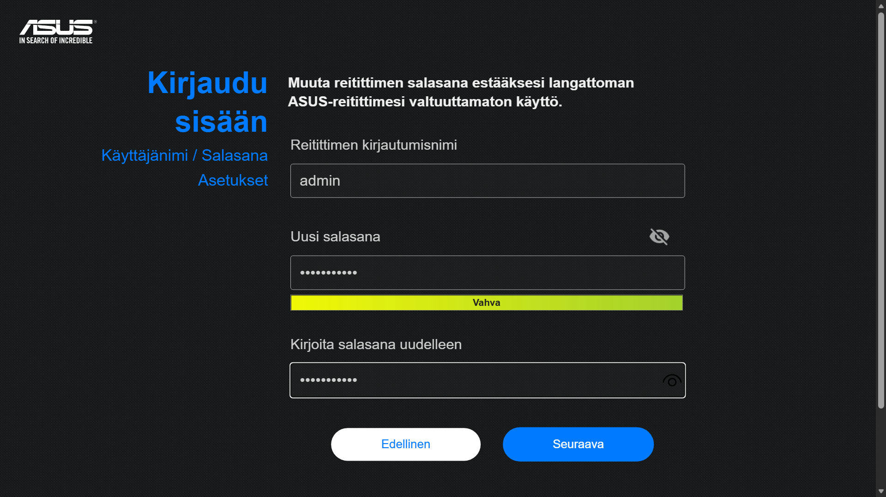
We then downloaded the newest software updates for the router which took a long time. It took a bit to find all the settings, but we were able to complete the second exercise of week 1 as well. Then we all connected to the network to complete the last assignment of the week!
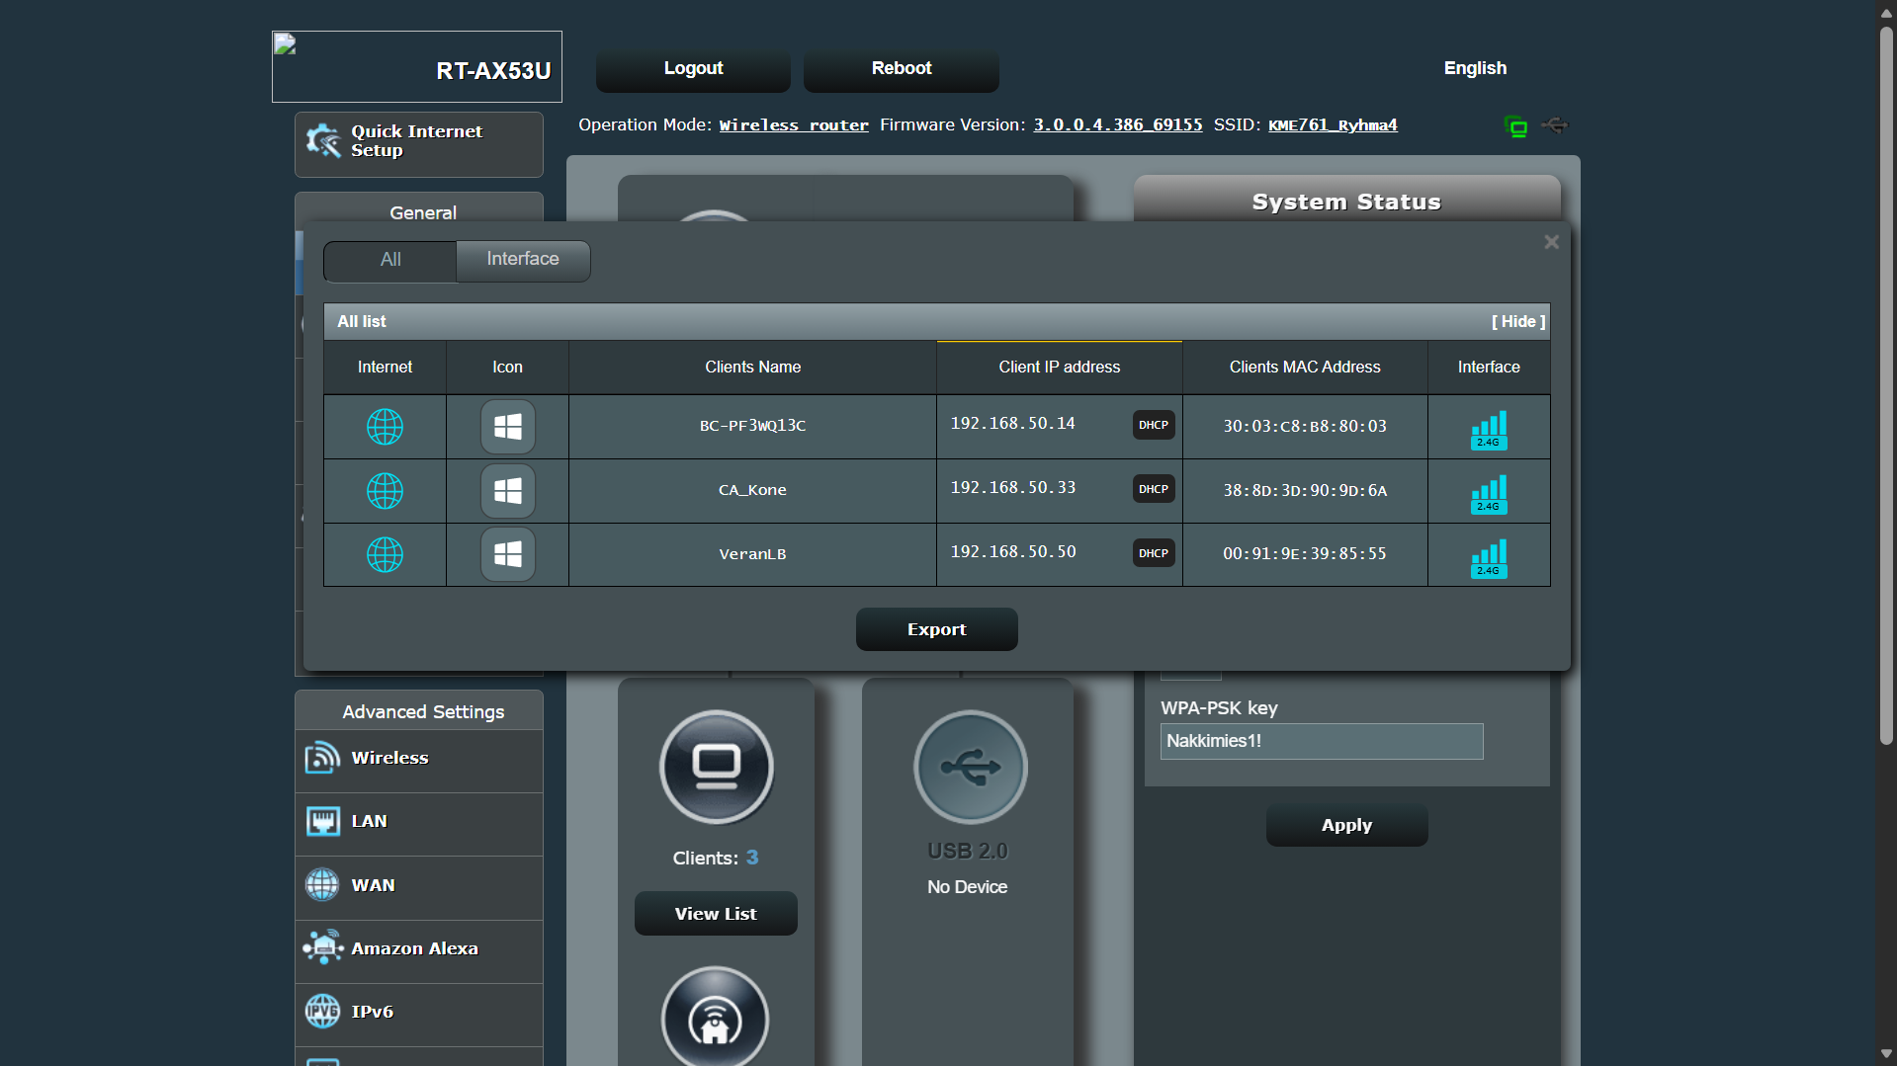

Test Results
Attach screenshots of your test results here. Remember to add captions to all images. Explain what was tested and how.

IP Addressing
On the Week 3: IP Addressing exercises you designed an IP addressing scheme for your network. Fill the information about your IP addressing scheme you in the tables below. Remember to list any used references in the reference list.
Table 1. IP address space.
Network address | 192.168.4.0/24
Subnet mask | 255.255.255.0
Number of bits reserved for the network address | 24
Number of bits reserved for hosts | 8
Maximum number of hosts | 254
First host address | 192.168.4.1
Last host address | 192.168.4.254
Broadcast address | 192.168.3.255

Table 2. IP addresses.
Router | 192.168.4.254
Raspberry Pi | 192.168.4.253
Raspberry Pi Pico | DHCP
Table 3. DHCP settings.
Network address | 192.168.4.0/24
Subnet mask | 255.255.255.0
Default gateway (router address) | 192.168.4.254
Reserved addresses
Router | 192.168.4.254
Raspberry Pi | 192.168.4.253
Available addresses
First address | 192.168.4.1
Last address | 192.168.4.254

Test Results
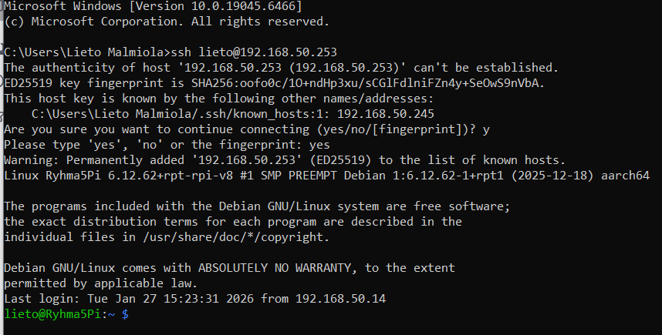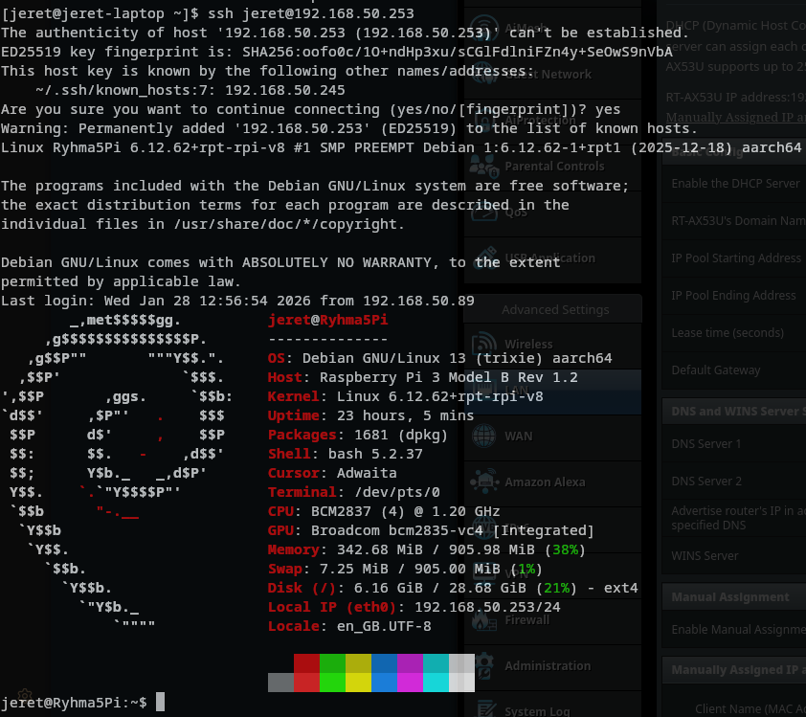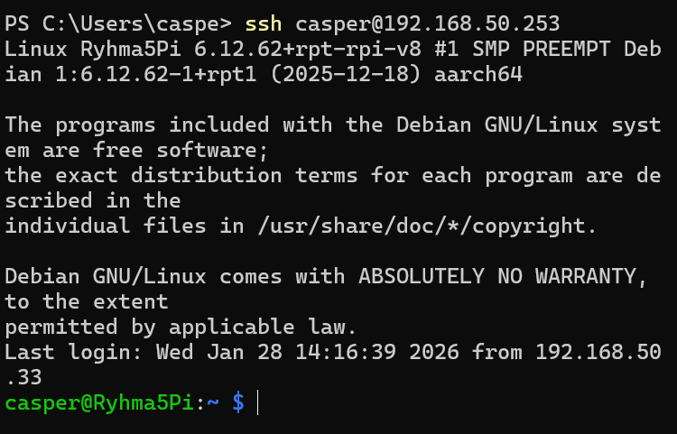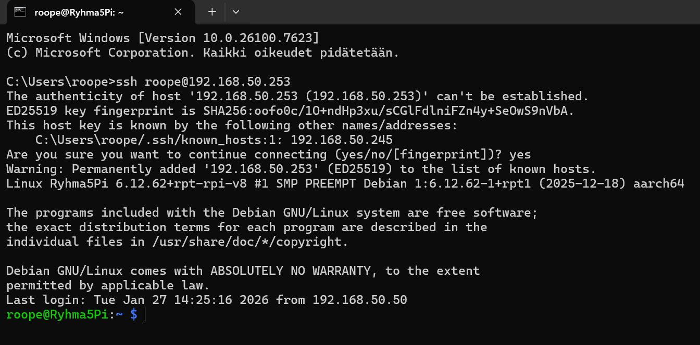

3.2
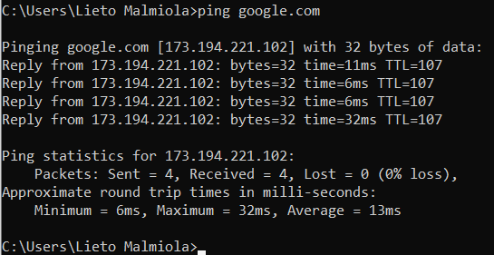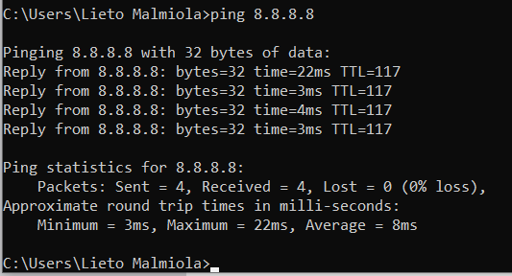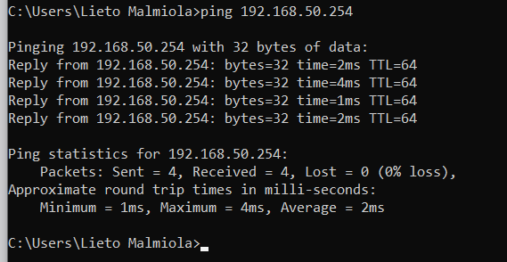

Setting up DDNS and Port Forwarding
Explain the steps you took when working on the Week 4: Setting up DDNS and Port Forwarding exercises. Remember to include screenshots and other illustrations. Remember to list any used references in the reference list.

Test Results
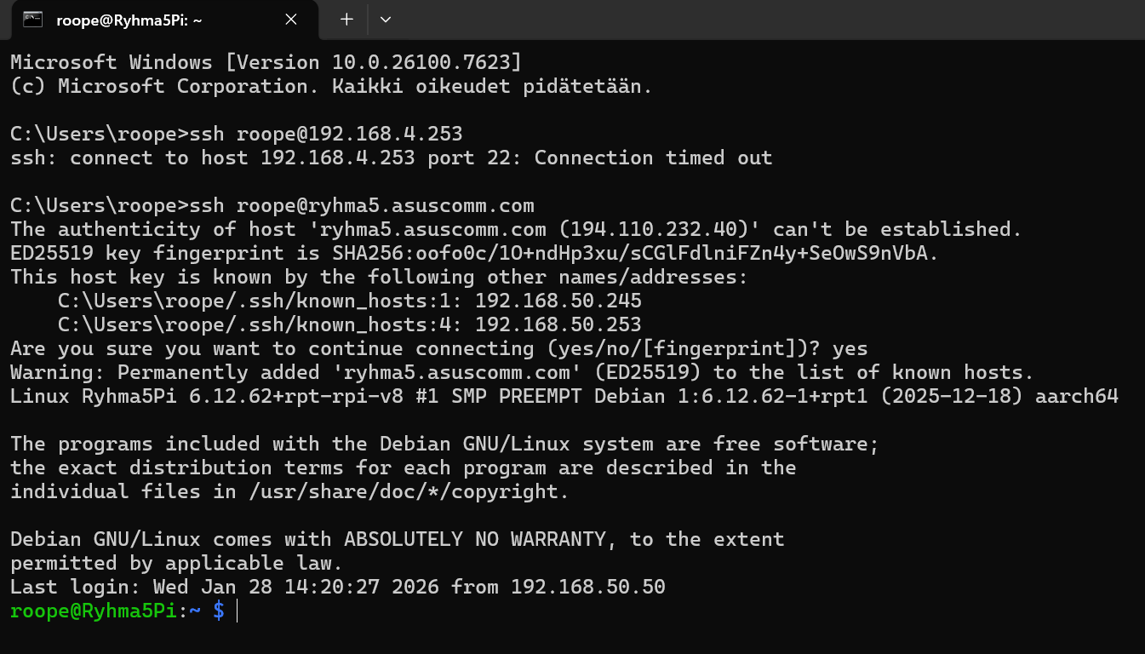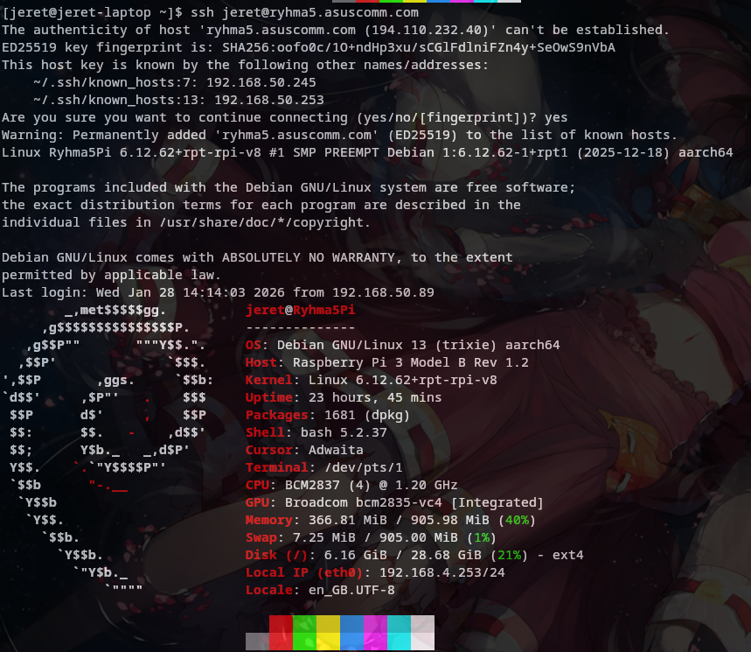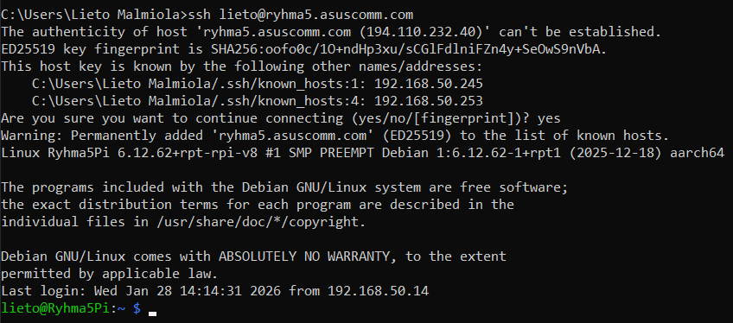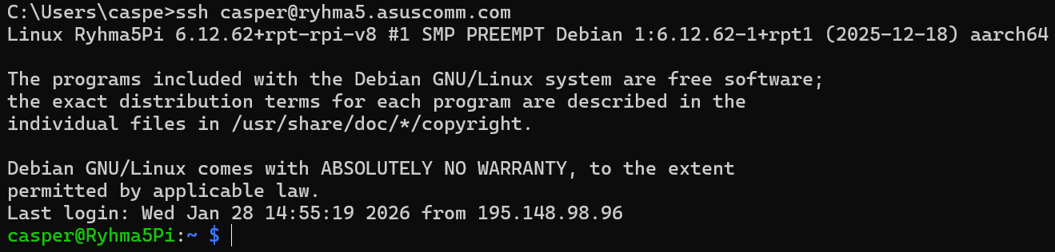

Setting up the Raspberry Pi Pico
Explain the steps you took when working on the Week 5: Setting up the Raspberry Pi Pico exercises. Remember to include screenshots and other illustrations. Remember to list any used references in the reference list.

Test Results
Attach screenshots of your test results here. Remember to add captions to all images. Explain what was tested and how.
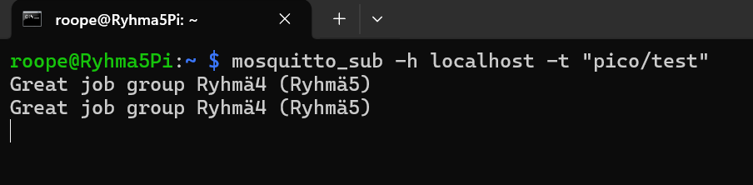
We tinkered with the scripts from gitlab a bit and got it working here is it working and our member roope receiving the mqtt pubs

References
List any references used in your final assignment.

